Annexure I

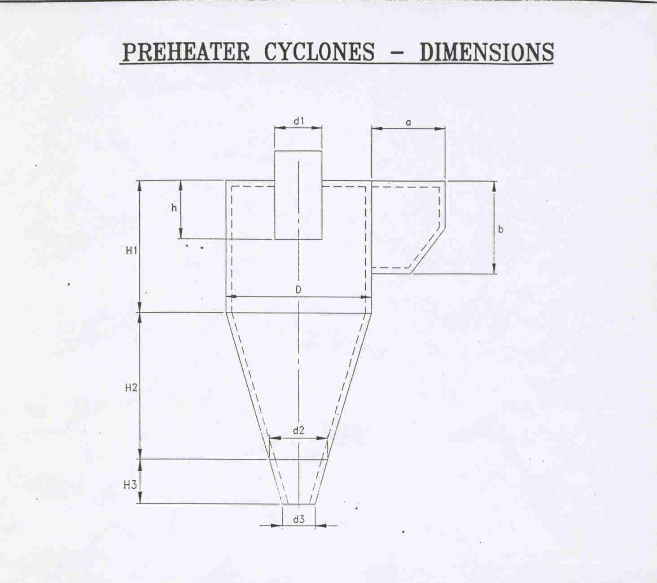
Dimension | Cyclone
 | I | II | III | IV | V | VI
D | 2.6 | 4.0(3.54 effective) | 3.8 (3.4effective) | 3.8 (3.4effective) | 3.8 (3.4 effective)
d1 | 1.42 | 2.02 | 1.498 | 1.578 | 1.578
d2 | NA | 1.32 | NA | NA | NA
H1 | 5.3m | 3.8 | 2.72 | 2.72 | 2.72
H2 | 2.72 | 2.9 | 3.0 | 3.0 | 3.0
H | 2.0 | 1.16 | 1.3 | 1.228(Effective) | 1.228 (Effective)
A | 1.0 | 1.0 | 1.45effective | 1.45 effective | 1.45 effective
B | 1.1 | 1.7 | 1.50 effective | 1.50 effective | 1.50 Effective)
H3 | NA | 0.5 | NA | NA | NA
3 | 0.30 | 0.35 | 0.35 | 0.35 | 0.35

